

CSE302: Database Systems (Section No.)
[Semester Year]

Project Report

Project/Application Title

Project URL/Link

Submitted by:

Student ID | Student Name | Contribution Percentage
2022-1-60-100 | Sadia Afrin Anamika
2022-2-60-148 | Marshia Nafisha

E-R Model of the Project

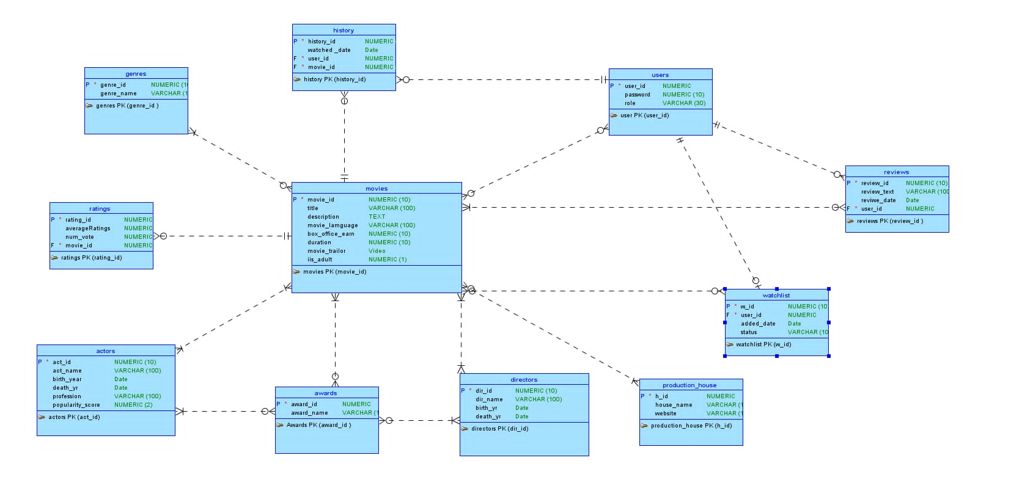

Relational Data Model of the Project

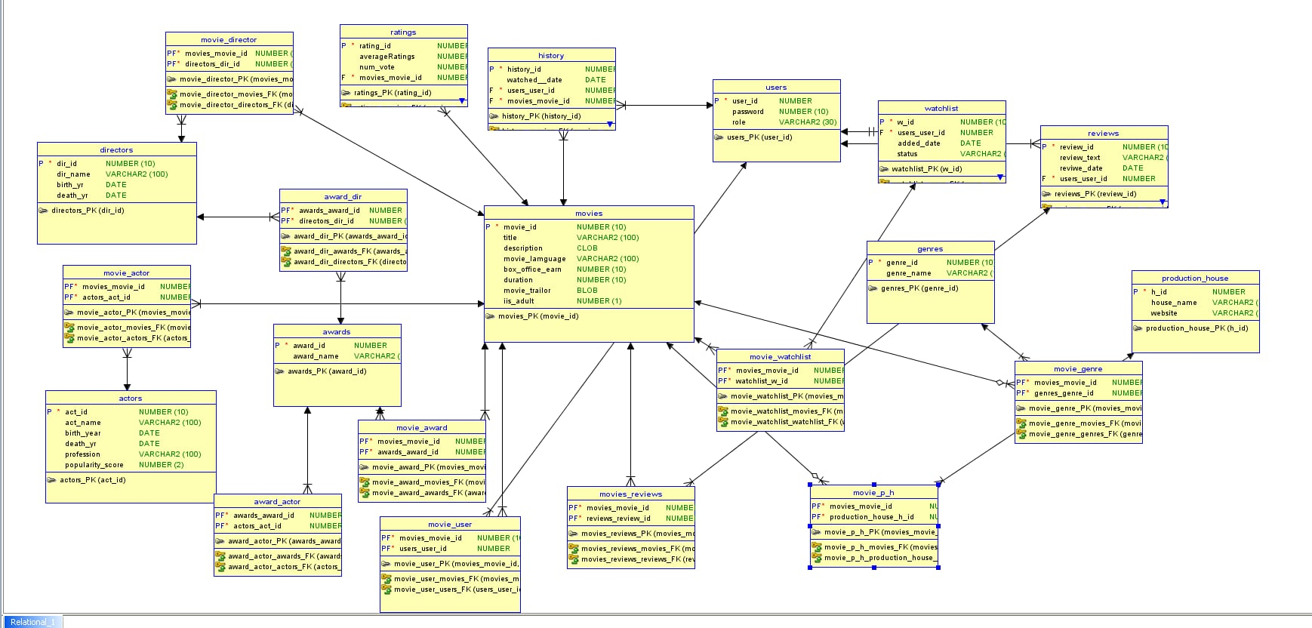

Database Normalization

Implementation Checklist

Description | Remarks
Project ID | Application 241927
Workspace Name | alack
Workspace Email | sadranalack@gmail.com
Workspace Password | onkpera_12345
Authentication Type | Application Express/Custom (keep the relevant one)
Username and Password to Login
write username like admin | write password like admin123
if you have multiple users, write all username and password correctly
Uploaded and Displayed Images in Reports | yes
Implemented Page-wise Authorization | yes
Number of Reports with Forms | 12
Number of Master-detail Forms | 4
Number of Reports based on Queries, Aggregate Queries | 4
Number of Graphs/Charts | 2
Included any trigger/other feature which is not taught in class. If yes, please explain briefly. | 2
Write the most unique feature/functionality in your application or the page of your application that you are proud of. Explain briefly.

Reports with Forms

Report Page Number and Name | Form Page Number and Name | Table

Use more rows if necessary.

Put screenshots of each of your reports and forms used for data input mentioning the name of the table in your database schema. Number your figures like 4.1, 4.2 and so on.

Master-Detail Form

Page Number and Name | Master Table (Parent) | Detail Table (Child)

Reports based on Multi-Table and Aggregate Queries

Page Number and Name | Query Type | Report description

Charts and Other Pages

Page Number and Name | Chart description

Authorization and User Role Assignment

User Role Assignment

User name | Password | Role
Example: admin | Example: admin123 | Example: Administrator

Page-wise Authorization Information

Page number and name | Authorization Level
Example: P1. Home | Reader
Example: P10000: Administration | Administrator

Use more rows if necessary.

Concluding Remarks

Write briefly about your experience during the project development. Write your raw feelings without any fear. I want to hear it! Thank you and Good Luck.

